RESIDENTS FAQ DOCUMENT
WARD 87 – JULY 2020

WWW.LOOKANDLOG.CO.ZA - WWW.JOBURG.ORG.ZA

Escalation of complaints
Please only ask me to escalate issues when the “lookandlog” turnaround time (SLA) has not been met.
Always log your complaint first if you have an issue, I can't escalate without a reference number.
Please send me your info in this format email or sms / Whatsapp
(Please only use Whatsapp if it’s a real emergency or outside office hours):
- Name
- Address
- Contact details
- Account No.
- Reference No.
- Description of issue.
My contact details:
- Email address: Bridget.steer@gmail.com
- Mobile: 083 604 0404
- Facebook page: Ward 87 Johannesburg– Cllr Bridget Steer.

REGIONAL DIRECTOR – REGION B Mr Mohau Ntheli – mohaun@joburg.org.za

URBAN INSPECTOR – Mr Phillip Miya – phillipmi@joburg.org.za 0833059719

BILLING & REVENUE –

NEW BILLING QUERY EMAIL ADDRESS IS DURING LOCKDOWN IS regionBrevenue@joburg.org.za

SEE COJ WEBSITE FOR GENERAL ACOUNT INFORMATION https://www.joburg.org.za/services_/Pages/City%20Services/Accounts%20and%20payments/Accounts%20Home/Accounts.aspx

Register to get your statement emailed to you
​​All you have to do is to register with the City's e-Services. Registration is free of charge. You will be asked to enter certain personal information and to choose a Username and Password. Remember to write down your username and password and keep it in a save place.
​To activate the process:
Logon with your username and password; Click on accounts by e-mail; Insert your account number and account pin (as printed on your original tax invoice) to continue with EAP; Select [Continue]; You can [Get Statements] or [Verify/Update your statement delivery details];
How do you access your statement?
• Schindlers Lawyers have put together a useful guide on how to use the site. https://bit.ly/2NS2ZJO

METER READINGS – SHOULD BE SENT BETWEEN 25TH AND 30TH OF THE MONTH
Meter reading schedule - https://www.citypower.co.za/customers/Pages/Meter-Reading-Schedules.aspx

ELECTRICITY READINGS ONLY FOR OLD METERS / BILLING ISSUES
please email estimations@citypower.co.za AND spencermph@gmail.com
OR SMS / WHATSAPP 0760167031 / 0710026543

WATER METER READINGS – meterreading@jwater.co.za / customer@jwater.co.za

What to do if your Electricity or Water Meter Readings are incorrect –

Take a photo of the meter (include reading, meter number and proof of date) and email COJ regionBrevenue@joburg.org.za the following information:

Name
Address
Acc No
Meter No
Meter Reading
Date
Please make sure photos are less than 2mb

NEW BILLING QUERY EMAIL ADDRESS IS DURING LOCKDOWN IS regionBrevenue@joburg.org.za

They will reply with a reference number. Please keep this so I can escalate any issues over 30 day (one billing cycle)

If you don’t have email you can call the customer centre 0113755555 or visit the nearest customer centre (Randburg or Thuso House Braamfontein)

ESCALATION OF BILLING ISSUES
AFTER 30 DAYS – Please email me your previous correspondence together with the latest statement and a photo of the current meter reading.

COJ RATES REBATES
Various rebates are available from CoJ. Please visit this site to learn more. The application forms are also available on the site.
https://www.joburg.org.za/services_/Pages/City%20Services/Rebates/Rebates.aspx

RATE CLEARANCE REFUNDS
https://www.joburg.org.za/services_/Pages/City%20Services/Refunds/Property-Refunds.aspx

CITY POWER

Please log all faults (power outages, streetlights, meter not working issues, securing a substation etc.) via the call centre 0113755555, citypower.mobi / https://za4.forcelink.net/forcelink/customportal/cp_mdt/customerportal.html#
Then SMS or Whatsapp me on 0836040404 the info in the following format in ONE message - no screen grabs please
Name
Address
Contact no
Ref no
Details of issue
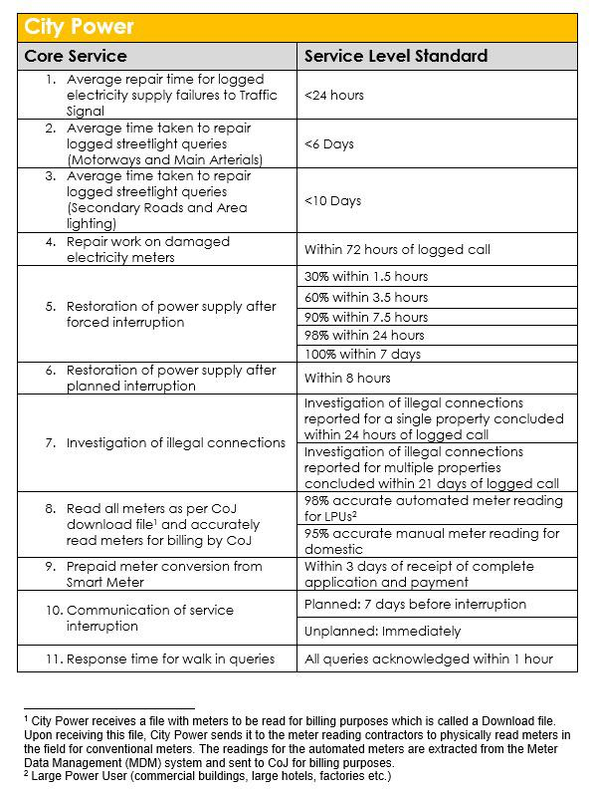
Electricity meter issues – wrong meter or reading on account
Please email Mboniseni Nevondo mnevondo@citypower.co.za and details as follows:
Name
Address
Contact no
Account number
Old meter number (and closing reading if you have it)
New meter number and actual reading
PLEASE TAKE A PHOTO (LESS THAN 2MB) OF THE CURRENT METER READING WITH PROOF OF DATE INCLUDED

Pre-paid meter conversion
You can only convert to prepaid if you have a smart meter and your CoJ account is current.
Please go the Randburg Walk in centre - Jan Smuts corner Bram Fischer.
This is a COJ process NOT a City Power process.
Most NB is to pay the fee AND get a notification number.
Keep the receipt safe in case you need me to escalate
To escalate prepaid meter conversions over 30 days (once your have made and paid for your application and have a 700 ref number) please email Dumo Zondi - dzondi@citypower.co.za

JOBURG WATER – EMAIL Customer@jwater.co.za / SMS 0763335052
Please log all water and sewer related issues (this includes leaks, bursts, missing water and sewer manhole covers) via the Call centre 0113755555 or email customer@jwater.co.za.

If it’s an emergency please SMS or Whatsapp me on 0836040404 the info in the following format in ONE message - no screen grabs please
Name
Address
Contact no
Ref no
Details of issue

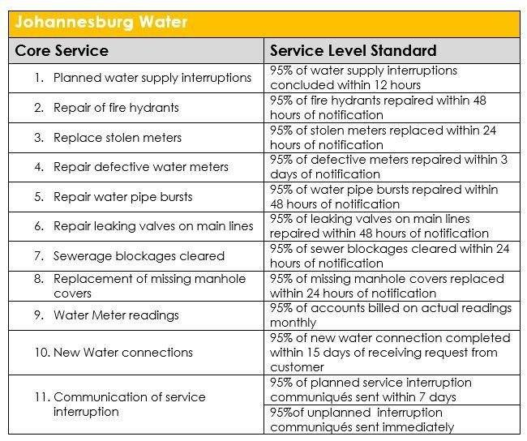

Water meter issues – wrong meter or wrong reading on account

Please email customer@jwater.co.za and joburgconnect@joburg.org.za the following details:
Name
Address
Contact no
Account number
Old meter number (and closing reading if you have it)
New meter number and actual reading
PLEASE TAKE A PHOTO OF THE CURRENT METER READING WITH PROOF OF DATE INCLUDED.

Checking for water leaks
If you suspect you may have a water leak, I suggest you close off all your taps and then see if the meter moves. If it does you need to call your plumber ASAP.

JOBURG ROADS AGENCY – hotline@jra.org.za

Please log all potholes, storm water, bridge, missing manhole covers in the road, skoffeling (weed / vegetation removal from traffic islands and pavements), road markings, traffic signs, and traffic light issues with Joburg Road Agency. Please always include very specific location details to assist the department.

Road resurfacing – Unfortunately there is limited budget for road resurfacing, so the focus is on main arterial roads at the moment. If you notice that your road is crumbling / cracking please log it to try and get it patched to prevent any further deterioration.

DAMAGES TO VEHICLES – CLAIM FORM
https://www.jra.org.za/documents/policies/REVISED_CLAIM.pdf

WAYLEAVE INFO
https://www.jra.org.za/customer-service/wayleaves

PIKITUP

Street cleaning / Illegal dumping / Street Bins
For the removal of illegal dumping call Joburg Connect on 0860 562 874 or 0860-JOBURG to log a call. Pikitup only attends to illegal dumping on pavements, streets and council-owned land; illegal dumping in parks is the responsibility of City Parks.
To report illegal dumping to Pikitup, call 011 688 1500 or email illegaldumping@pikitup.co.za. Once you have a reference number please email Melvin to escalate it - melvinj@pikitup.co.za
Replacement Bins
There are four categories of bin replacements:
1) If you have no bin at your house - i.e. it is a new house or you have purchased one and there was no bin. You apply to Pikitup and the bin is free.
2) If you want a second or more bins, you contact Pikitup and pay R385 plus VAT per bin.
3) If your bin has been stolen or gone missing. You can get ONE free bin replacement every 8 years starting from 1 July 2017. After that you pay per bin.
4) If your bin is broken or damaged, then you will get a free bin, proving that you return the old bin.

The Process to Obtain a Bin
In each of the above options, you need to call the COJ call centre on 011-3755555 and obtain a reference number. You will need your account number when you do this.
If it has been stolen, then you should first visit your nearest police station and report it. You will need to provide the case number when calling the COJ call centre.
If you need to pay for the bin(s), then you need to go to your Regional Walk In Centre (for Ward 87 it is Randburg, corner Jan Smuts Ave and Braam Fischer Drive) with the reference number, a copy of your municipal bill and cash to the value of R385 plus VAT per bin.
In theory, Pikitup will then alert the depot that services your suburb and deliver a bin within a week or so depending on stock availability. If you haven’t received your bin after a month please email Ronel Doria - ronelld@pikitup.co.za
- Name
- Cell / contact number
- Address
- Ref number
- Attach a copy of the receipt if you have paid for a bin.

CITY PARKS

TREE TRIMMING OR REMOVAL – It is illegal for any resident to trim or remove a tree on city property. If you need a tree trimmed or removed, please report it to CoJ and get a reference number, then fill in this form (https://drive.google.com/file/d/18TaQIomIjoUO9utVuq7V3Mk1Ym1Ht3dv/view?usp=sharing)

And email it to Alton Rankin – arankin@jhbcityparks.com

Parks maintenance – please also email Alton

Trees that have fallen into the road – please call 0113755555 selection option “0” for the emergency tree felling team and get a reference number,

JMPD

0113755911 for bylaw enforcement
Hotline for traffic related issues 0808723342
Hotline for illegal dumping 0800120555 OR 0827791361

JMPD are responsible for Bylaw enforcement in COJ.
Public nuisance, public drinking, noise, reckless driving etc.

Illegal structures / shacks being erected in open spaces – Please call JMPD 0113755911 and get a reference number. Please then email Region B JMPD Chief Mike Smith mikesm@joburg.org.za and cc the Regional Director Mohau Ntheli mohaun@joburg.org.za with the location and reference number.

Illegal dumping – If you witness illegal dumping please report to the hotline 0800120555. Try to take photos and get details of the vehicle registration so the culprits can be tracked. (Or whatsapp or email me the same info)

ENVIRONMENTAL HEALTH

Any environmental health issues (over grown stands, overcrowded buildings, etc.) should be reported to Bernadette Getz bernadetter@joburg.org.za

NOISE NUISANCE

Please follow the procedures on the document to report noise nuisances.
https://drive.google.com/file/d/1hCWKq-hbYeh-HXzBL6r8BUfAdWiryBW2/view?usp=sharing

Ashendri Reddy - AshendriR@joburg.org.za

SOCIAL WORKER –
Jennifer Qupe 0671272211 jenniferq@joburg.org.za

DISPLACED / HOMELESS PERSONS –
Kebonye Senna 0822549500 kebonyes@joburg.org.za

For the moment displaced persons can seek the City’s help at:
3 Kotze overnight shelter (linked to Governors House)
Governors House assessment Centre 28 Kotze Street and Queens Road, Hillbrow
Windsor West assessment Centre 23 Knights Street, Windsor West
Dan Street assessment Centre 1 Dan Street, Florida and the gate is on 4th Avenue

If anyone knows of a displaced person who would willingly go to one of these locations for shelter, please contact 083 702 6806 or 083 702 6807, and the relevant people will be sent to relocate them. Residents can also contact the City’s Displaced Persons Unit on 011 407 7274.

DEVELOPMENT PLANNING

ILLEGAL LAND USE

This department deals with businesses operating illegally.
If you suspect that this is happening please report it to Joseph Geduld via email to josephg@joburg.org.za.

Please give address and as much detail as possible. Examples of illegal land use are communes, churches, and businesses operating from residential stands. You can check the zoning using this tool on your mobile phone – just zoom into the property in question – ags.joburg.org.za, or use the COJ GIS system to check https://eservices.joburg.org.za/new-maps

BUILDING PLANS / PERMISSION

Any new building and any alteration that adds on to or changes the structure of an existing building must go to the City's (Planning) Development Management Department for approval.​
You can check if plans have been submitted by using this portal - https://eservices.joburg.org.za/Pages/BuildingPlans.aspx

Alternatively please contact our Building Inspector – Faried Watson fariedw@joburg.org.za

Historical/archived building plans will be available to the public, but only through appointment by email or telephone (Email address: KgolokoPatrickK@joburg.org.za and Tel: 011 407-6034/ 083 702 7689) and request a copy of a plan, then set an appointment for collection. The plan will then be collected at the Metro Link.

LAND USE DEVELOPMENT MANAGEMENT

1. Submission of Land Use and Legal Admin applications

As of Monday, 01 June 2020, the Department will accept applications electronically on:
Land Use Applications – landuseapplications@joburg.org.za
Legal Admin Applications – legaladminapplications@joburg.org.za

Once the applications are assessed, an invoice will be issued to applicants, with details for an EFT payment. Applications are only registered once proof of payment is received. For enquiries, contact Ben Pretorius. Contact details available in Annexure A.

Additional supporting documents for Land Use Applications and Legal Administration will be done via email. Members of the public/applicants should refer to the City’s planning website for further details on
the submission process of applications electronically.

Details of the electronic submission of applications, referred to above, will be uploaded on the City’s website upon finalisation by the Department, ahead of 01 June 2020.

2. Processing of applications

Applications that are currently in the system and are complete; i.e. do not require outstanding comments from municipal entities, State Departments and no public participation, will be processed and concluded.

3. Advertising of applications

All applications that require advertising for public participation will be pended and will only be advertised once lockdown levels allow for general public participation on planning matters.

4. Submission of objections

Objections to applications continue to be submitted to ObjectionsPlanning@joburg.org.za, but these need to be read alongside paragraph 3 above. Applications advertised during the lockdown and those that close under the lockdown will be extended by 28 days, once the lockdown is lifted.

5. Circulation of applications

Applications will be circulated internally electronically to the Municipal Owned Entities (MOEs) and Departments to allow staff from both MoE’s and LUDM to access, in order to process applications and to provide comments. Circulation to the external departments will also be done via email.

6. Responding to enquiries and follow-ups on applications

Enquiries and follow-up on applications will be limited to email or telephone to the respective teams in the Department, as listed in Annexure A.

7. General communication with applicants

No face-to-face consultations; however, general communication will be conducted with officials via email or telephone.

8. Convening of Municipal Planning Tribunal (MPT)

MPT hearings will not be reconvened under Level 4 for all applications; unless on exceptional circumstances, where necessary, and at the discretion of the City, to consider applications that align with stipulations of Covid-19 essential municipal services. Such a tribunal hearing will then only be convened and conducted using media platforms, such as teleconferencing and videoconferencing, where practically possible.

In case officials mentioned in Annexure A are not available, please contact the Director, Nokuthula Thusi, on NokuthulaT@joburg.org.za or 083 702 3955.

BUILDING DEVELOPMENT MANAGEMENT

The Building Development Management Directorate is only considering public works developments and emergency applications, in line with COVID-19 Level 4 Lockdown regulations. Public works developments
include hospitals, clinics, etc. Emergency applications will be for all COVID-19 related works, including temporal structures and purpose made alterations. The approach is in two phases:

1. The Department has been processing emergency applications since the national lockdown was initiated, and will continue prioritising emergency applications.

These are processed via the office of the Building
Control Officer (BCO). Applicants are required to submit critical documents, i.e. Structural Engineers Certificate, Fire Certificate, Plumbing Certificate, and Glazing Certificate. Photographic evidence is also required. Once all requirements are met, the BCO will grant authority for construction to continue with the provision that building plans are submitted later.

Building Inspectors are working from home and have been on standby throughout the lockdown to respond to emergency issues. They also conduct basic site inspections prior to the issuance of any temporal occupation certificate.

For more details, contact the Deputy Director: BCO, Broderick Chiloane, using contact details list below.

2. The Directorate is finalising the opening of the Metrolink to allow for the submission of public works developments and emergency applications. This will be conducted under strict COVID-19 regulations.

Members of the public should note that construction permitted under Level 4 is limited, and that correct procedures are meant to be followed. There will be adjustments to the procedures and types of building plans accepted during all lockdown levels, alongside the limited staff, as they are phased in.

Furthermore, staff working at Regional office will work on a rotational basis. Approved building plans can be collected at the Regional offices once the owner has been notified. Members of public without a mask will not be allowed inside the offices.

Regional Assistant Directors (Annexure A) may be contacted for all emergencies and contraventions.

For any further enquiries, please contact the Acting Director, Gcina Makhubu, on GcinaMa@joburg.org.za, or call 083 7024985.

CORPORATE GEO-INFORMATICS

All CGIS walk-in queries are suspended until further notice, however a range of electronic services are available.

Contact details of officials available in Annexure A.

1. Online Mapping Website

This service has been available online throughout the lockdown period. All Online Mapping website related requests may be sent via email to Roxanne Parthab until the lockdown is lifted.

2. Property Information Services

Property Information Services e.g. ownership and property information queries continue to be available via e-mail. All electronic processing of data e.g. Deeds data is also continued, based on the availability of data from the Deeds Office. All processing of LIS related data to SAP is also continuing. Ownership queries and property status queries may be directed to the relevant listed officials. Please state property description (erf number, township name, etc.) in all communication. All walk in queries are suspended until further notice.

3. e-Property Information Services

All CGIS customer queries: cgisCRM@joburg.org.za
For Surveyor General diagrams/plans, customers may go to http://csg.dla.gov.za or email sgdatagp@dldlr.gov.za.

4. GIS Project Section: Digital data and digital mapping

Digital Data and mapping requests can be sent via email to cgisprojects@joburg.org.za.

5. Cadastral, Zoning and Street Address capturing and requests

Capturing continues with work from home arrangements. Queries restricted to emails and telephone.

For Data Admin and Mapping, contact Vincent Mkhwanazi and Rianna Rossouw for Spatial information.

For any further enquiries, please contact the Director, Marcelle Hattingh, on MarcelleH@joburg.org.za, or call 082 467 9277.

LAW-ENFORCEMENT UNIT

The Law-Enforcement Unit, identified as an essential service, has continued throughout the lockdown. The directorate has managed to attend to complaints; conducted investigations, both desktop and on site;
attended to litigation queries; and coordinated a building demolition.

Since the declaration of Level 4 lockdown, the directorate has put in place measures to continue providing relevant services to communities on a rotational basis. Senior Law Enforcement Officers will be available to conduct respective compliance inspections while working from home. Members of the community are therefore encouraged to report any built environment contravention using the dedicated email address:
ComplaintsPLE@joburg.org.za, or alternatively contact the relevant operational manager in the annexure below.

For any further enquiries, please contact the Director, Mpho Molongoana, on MphoMolon@joburg.org.za, or call 083 702 7002.

CITY TRANSFORMATION

The Directorate is responsible for the co-creation and implementation of urban policies that guide investment in the City. The implementation of these policies requires the Directorate to engage with external stakeholders from time to time. The services offered by City Transformation and Spatial Planning to the general public and other clients remain open during all levels of lockdown. No face-to-face consultations are permitted – all meetings can take place on Microsoft Teams. Queries relating to planning policies in the City can be directed to officials indicated in the annexure, below.

For any further enquiries, please contact the Director, Eric Raboshakga, on EricR@joburg.org.za, or call 0814727889.

