George Hay Park Survey

July 2016

Background
Following certain complaints received about events held at George Hay Park, the Parkview Residents’ Association (PRA) and Ward Councillor, Amanda Forsythe, designed a short survey to understand how many people are being affected adversely, and positively, by these events. A further objective of the survey was to understand whether changes in approach to how events are done at the park are needed, and/or whether certain events need to be relocated.

Survey participants
Invitations to complete the survey were sent to residents in Parkview (via the PRA database, members of the Ward Councillor’s database. Invitations were also sent out via relevant social media websites.

262 responses were received. This corresponds to a precision on reported estimates of 6.1%.

It is not possible to estimate the response rate since some open channels of invitation (social media websites) were used and thus the total number of people invited to complete the survey cannot be estimated.

Use of George Hay Park
78% of the respondents were regular users of the park, while 22% were not.

How the park is used
The most popular use of the park is the attendance of events (73% of respondents). Other popular uses of the park are walking of dogs (46%), walking (43%) and children playing (43%). Only 7% of the respondents reported that they did not use the park at all.

These results indicate overwhelming support for events held at the park.

Attendance of events at the park
97% of the respondents indicated that they had attended events at George Hay Park; 54% had attended many events there. Only 2% of the respondents indicated that they had not attended any events in the park and did not wish to do so.

Events attended at the park (amongst the 97% of respondents who had attended events)
The most frequently attended event at the park was the Christmas market (97% of respondents), followed by Halloween (67%).

These results show that even large events such as the Christmas market, are well-supported by local residents.

Events at the park which are deemed to be problematic
73% of the respondents deemed NO event to be problematic, which is again a positive endorsement of these events within the local community.

Events at the park which are enjoyed
The Christmas market and Halloween were the two most loved events, enjoyed by 70% and 46% of respondents, respectively. This reflects the earlier results on the most frequently attended events.

The main reasons why these events are well-loved were the sense of community, and that the events are for the whole family. The Christmas market is enjoyed additionally for its charitable aims.

Concerns about events at the park
50% of the respondents had NO concern about the events, which is a positive reflection on the manner in which these events are managed. Chief concerns were those typically associated with outdoor events, namely traffic congestion (23% of respondents), and litter (23%), which should be brought to the attention of event organisers.

Possible solutions for problems around the events at the park
Given that the two largest concerns around the events were traffic congestion and litter (see previous section), it is not surprising that requiring event organisers to address these were among the most popular solutions (47% and 59% of respondents, respectively). Although environmental damage to the park was not listed as a main concern relating to the event, 58% of the respondents nevertheless felt that it wold be fitting for event organisers to donate a portion of their proceeds towards rehabilitation of the park.
Notably, limiting the number or size of the events were not seen as appropriate ways of dealing with the concerns around the events – another indication of the popularity of the events.
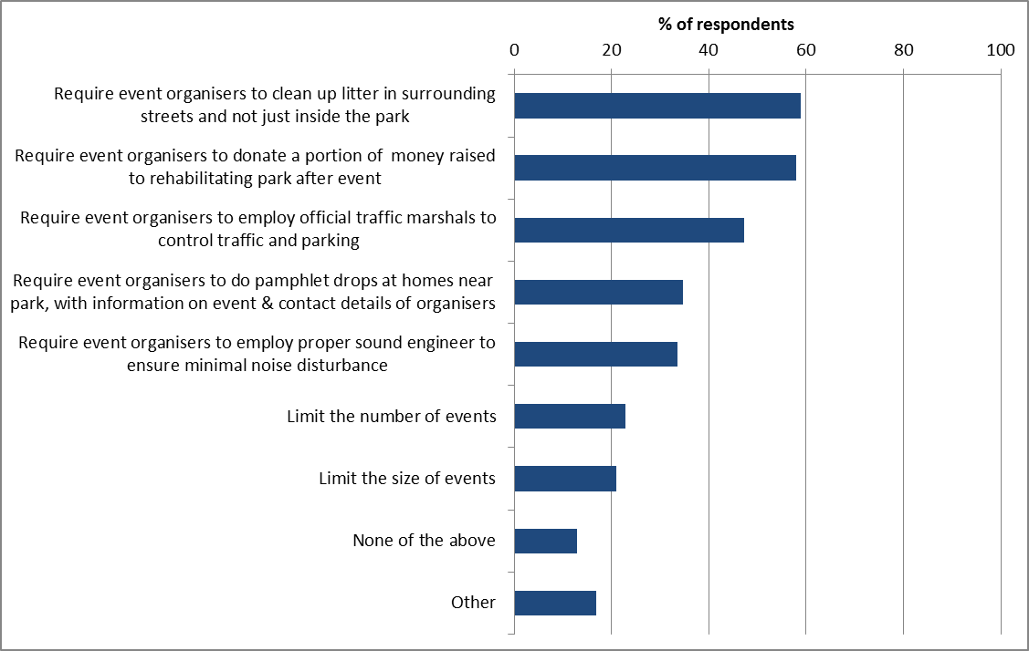

Communication of the results of the survey
95% of the respondents preferred to receive the results by email; the remainder preferred to receive the results telephonically or at a public meeting.

This report was compiled by:
Dr Petra Gaylard
Consulting Statistician
For the Parkview Residents’ Association
July 2016

